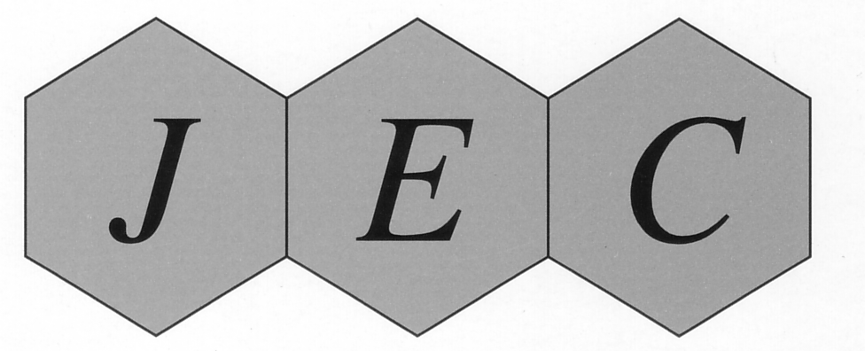Fax：+81-(0)29-886-3186 Mail：office@j-ec.or.jp
Please fill and return this form by FAX or MAIL to:
Japan Society for Environmental Chemistry
Ogawa Bldg.,3F ,Koyadai, Tsukuba, IBARAKI 305-0074 Japan

Application Form for the Membership of
Japan Society for Environmental Chemistry

I desire a membership in Japan Society for Environmental Chemistry from 2 0 (year).
Type of Membership (please check one): Overseas Membership *Domestic Membership
The annual membership fee : Overseas Membership￥12,000 / Domestic Membership￥8,000
*If you apply to the domestic membership, please inform us your address in Japan.
(Bank transfer fee is not included in this amount. Please burden this at your expense. Thank you.)

Application Date: (month/date/year)

Name: (Prof. Dr. Mr. Ms.)
Last Name First Name Middle Name
Name in Chinese Character, if you have:
Date of Birth: (month/date/year)

Delivery address for the journal of Japan Society for Environmental Chemistry: (please check one) Office Home No need

Office:
Office Address:

TEL: FAX:

Home Address:

TEL: FAX:

E-mail:

Final Education: Year:
Degree: Present Position:
Special Field of Interest:

Notes: The journal of Environmental Chemistry (4 issues / year) is sent to the member upon publication.

